# Localization (Multi language support Ionic App)

Create new ionic project using command **Prompt**- ionic start <project name>

D:\> ionic start Multi-language-supported-Ionic

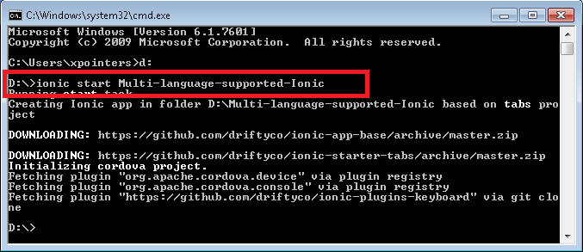

This will create simple project. Now, you can find project folder with following structure.

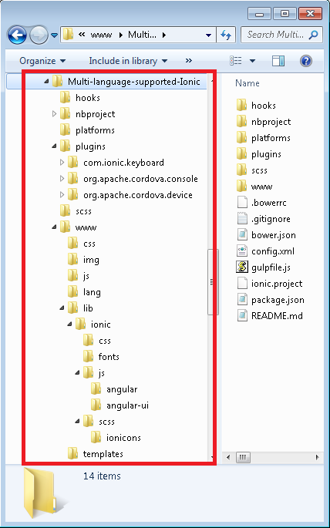

Before, Implementing Multiple Language app-

1. Download **angular-translate.js** from<https://github.com/angular-translate/bower-angular-translate/blob/master/angular-translate.js>**.** This is providing by Angularjs.
2. Add angular-translate.js file inside **“www\lib\ionic\js\angular\ ”**
3. Include ***<script src="lib/ionic/js/angular/angular-translate.min.js"></script>*** on index.html page.
4. Now, Add **“language”** folder inside “**www**”
5. Add JavaScript file of respective language inside language folder.

**Ex-**

* For English -> en.js
* For Hindi -> hi.js

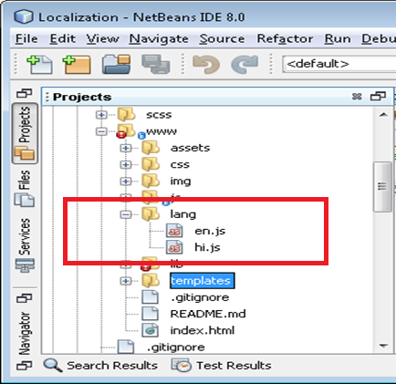

1. Add script tag on **index.html** file.

Ex-

* <script src="lang/en.js"></script>
* <script src="lang/hi.js"></script>

If you want add other language, you can. For that, first create java script file of respective language (like Hindi and English) and add script tag on index page.

1. Added following code in **app.js**.

config(function($translateProvider) {

// variable name - translations_en , translations_hi. Which is declared in language js file

//Language code – en and hi

$translateProvider.translations('en', translations_en);

$translateProvider.translations('hi', translations_hi);

$translateProvider.preferredLanguage('en');

})

Ex-

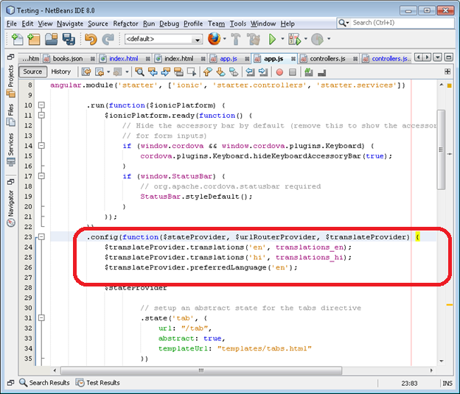

1. Add following attribute **['pascalprecht.translate' ]** in controller-

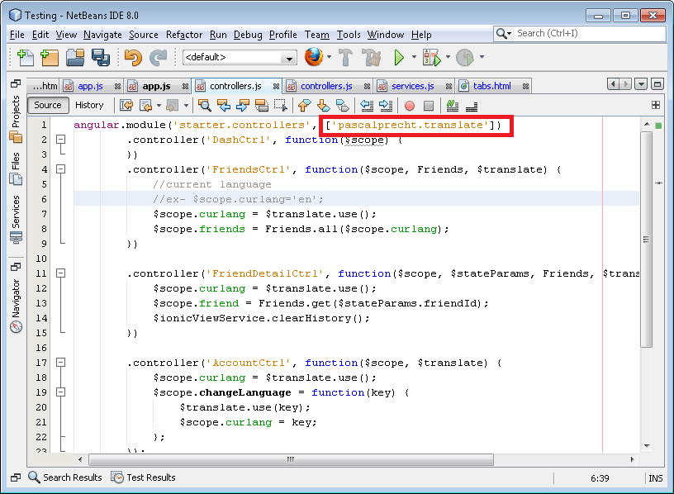

1. Add code in Controller-

angular.module('starter.controllers', ['pascalprecht.translate'])

.controller('DashCtrl', function($scope) {

})

.controller('FriendsCtrl', function($scope, Friends, $translate) {

//current language

//ex- $scope.curlang='en';

$scope.curlang = $translate.use();

$scope.friends = Friends.all($scope.curlang);

})

.controller('FriendDetailCtrl', function($scope, $stateParams, Friends, $translate, $ionicViewService) {

$scope.curlang = $translate.use();

$scope.friend = Friends.get($stateParams.friendId);

$ionicViewService.clearHistory();

})

.controller('AccountCtrl', function($scope, $translate) {

$scope.curlang = $translate.use();

$scope.changeLanguage = function(key) {

$translate.use(key);

$scope.curlang = key;

};

});

**Now, how we can display listing and description?**

**There are following step for Listing and description with different language-**

1. Now, Call Factory from controller –

$scope.curlang = $translate.use(); //Current selected language

$scope.friends = Friends.all($scope.curlang);

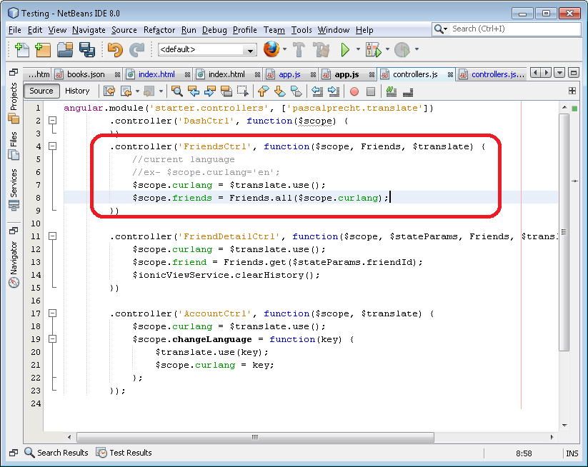

1. Declared factory “Friends” in services

* In that, Getting data from json file (**friendlist.json**).
* **friendlist.json** file content Item list and Item description with different languages.

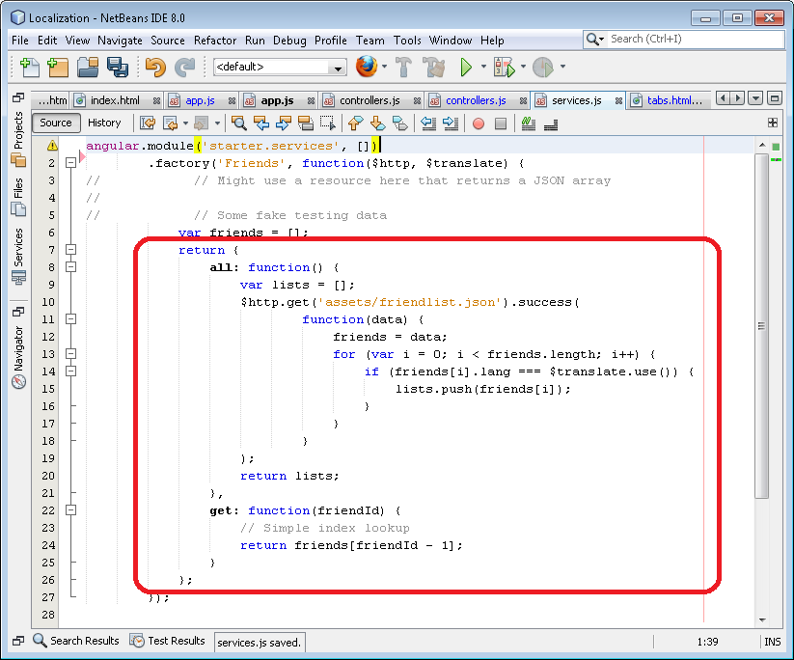

1. Return array to controller as per the current language.
2. Now, you can display Listing in using ***ng-repeat*** on Template.

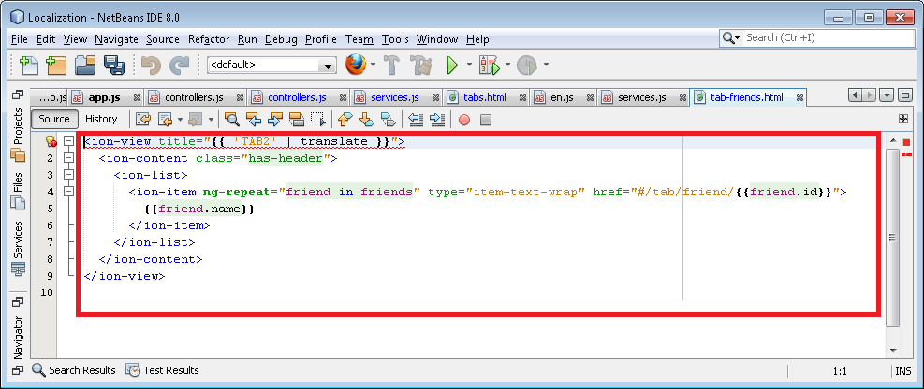

1. Create variable in different language js file. Which will display on template

* Variable name should same in all language js file and
* Value will be different as per the language.

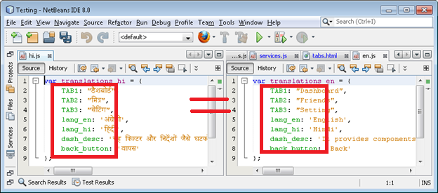

1. Replace all Template **Hardcoded text** to **variable** which is declare in ***en.js, hi.js***

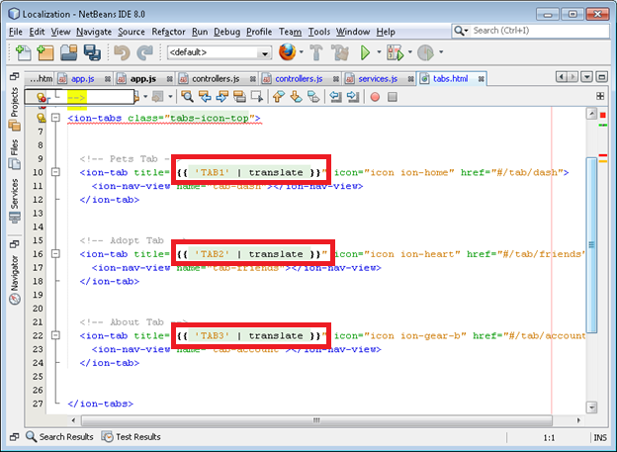

After all the changes, Application is ready to run on device. Following are the screen short of App-

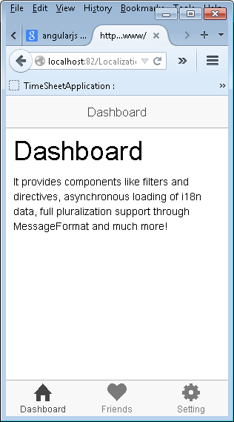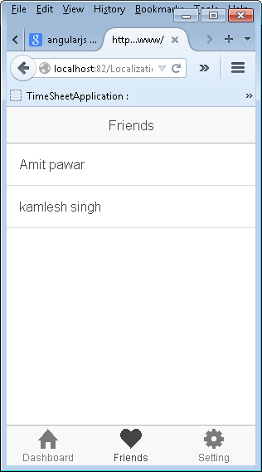

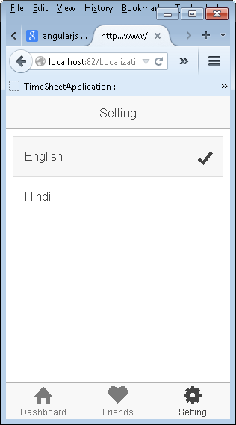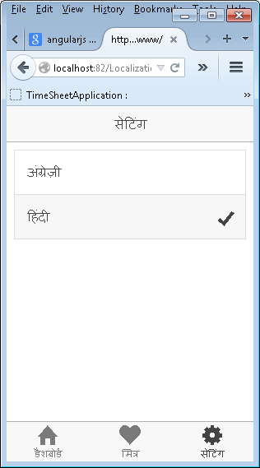

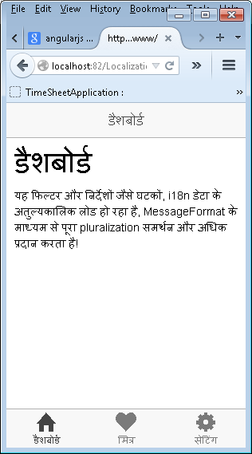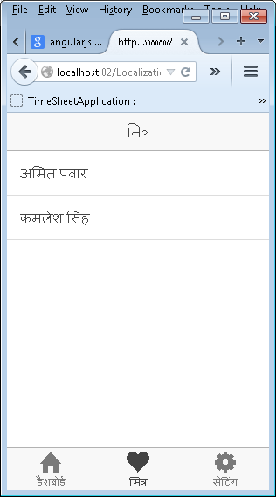

**Important Link-**

1. <https://github.com/shashikantkumar88/Multi-language-supported-Ionic-App>

*(You can download code of project from above link)*

1. <http://angular-translate.github.io/>